Hot drinks
Espresso £1.60
Double espresso £2.00
Americano £2.00
Latte £2.35
Cappuccino £2.35
All coffees are available as decaffeinated upon request

English breakfast tea £2.10
Earl Grey tea £2.10
Peppermint tea £2.10
Camomile tea £2.10

Hot chocolate £2.35

Ramsbury Tea products are available to buy in gift packs of fifteen at £3.99


Free WiFi is available - please ask at the bar.

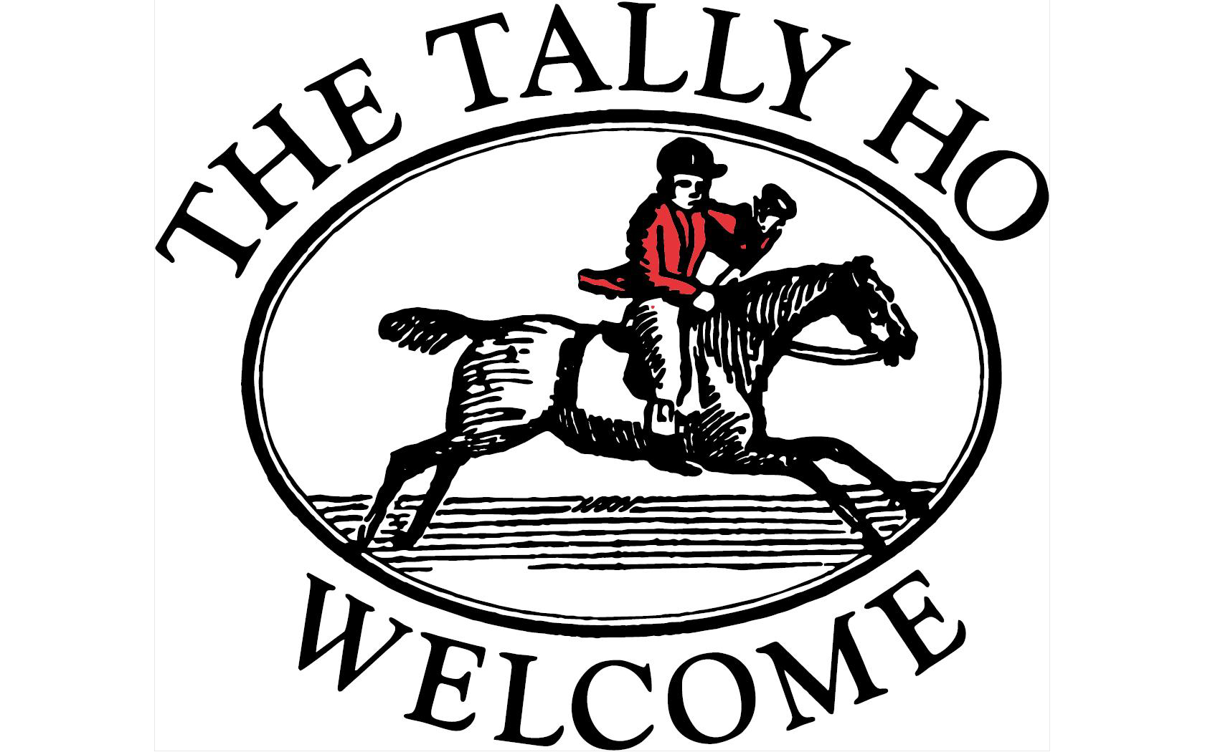

Hungerford Newtown Berkshire RG17 0PP

Tel: 01488 682312
Email: welcome@thetallyhohungerford.co.uk
www.thetallyhohungerford.co.uk
www.facebook.com/TheTallyHoHungerford

Sunday Lunch Menu

Available 12 – 3pm

Lunch menu available Monday to Saturday 12-2pm
Evening menu available Monday to Thursday 7 – 9pm
Friday / Saturday 6.30 – 9.30pm

To start
(v) Home-made soup of the day (please ask) with fresh bread and butter £4.50
Crispy tempura king prawns with a soy, sesame, cucumber salad and
sweet chilli dipping sauce £6.00
(v) Creamy button mushroom risotto with parmesan and pea shoots £5.25
Panko crumb calamari with a garlic and lemon mayonnaise £5.95
(v) Beetroot and roast sweet potato salad with goats cheese,
toasted cashews and a balsamic reduction £5.50
Proscuitto wrapped wild boar and Cognac pate with warm crusty bread
and fig relish £6.25
(v) Rosemary baked Camembert to share with garlic bread £10.00

The chase
Prime topside of beef with all the trimmings, Yorkshire pudding, roast
potatoes, fresh vegetables and rich home-made gravy £13.50
Roast pork with roast potatoes, Yorkshire pudding, fresh vegetables, apple
sauce and rich home-made gravy £11.95
Roast chicken supreme with roast potatoes, Yorkshire pudding,
fresh vegetables and rich home-made gravy £11.95

Something different:
Slow cooked beef and ale pie with buttery puff pastry, mashed potato
and seasonal roasted vegetables £11.50
Chicken breast in a creamy garlic mushroom sauce with spinach,
leeks and long grain rice £11.95
Venison steak with cranberry and orange sauce, mashed potato, roasted
vegetables and parsnip crisps £12.25
Fish pie with sweet potato topping, roasted cherry vine tomatoes, peas £10.50
Sausage and mash of the day (please ask) with seasonal vegetables and gravy £10.00
Spaghetti carbonara with parmesan, rocket and garlic bread £9.95
(v) Roasted cherry tomato, caramelised red onion, goats cheese,
mozzarella and spinach tart with chips and house dressed salad £9.95
(v) Vegetarian bubble and squeak with hollandaise sauce, fried Benham Estate
hens egg and steamed green beans £9.50

Please see separate specials board

As all our food is freshly cooked, please be prepared for a short wait
Please be aware most of our chutneys and condiments are produced in a factory where treenuts, gluten, eggs, sulphur dioxide, milk, soya, celery and fish are all handled

Small portions menu
Half portions are available on all our roast dinners at half price

Jumbo pork sausage or fish fingers or honey baked ham £5.95 each
All served with mashed potato or rice or chips plus choice of salad, baked beans or peas

Vanilla ice cream and wafer £1.00
Sticky toffee and ice cream £2.50
Crumble and ice cream £2.50

The spoils
A selection of homemade desserts are available. Please see separate chalkboard
Cheeseboard Stilton, creamy mature cheddar, goats cheese with Jacobs crackers selection, sliced apple, celery and caramelised tomato and red onion chutney £6.95

Dessert wine
Domaine Grange Neuve Monbazillac 70ml £4.30

Port, Sherry & Brandy

Port Souza Ruby 70ml £4.10
Taylors Vintage Port 70ml £4.20
Krohn Ruby Port 70ml £4.20
Krohn LBV Port 70ml £5.60
Harveys Bristol Cream Sherry 70ml £3.30
Fernando Castillo Fino Sherry 70ml £4.50
Colosia Fino Sherry 70ml £4.50
Courvoisier 25ml £3.10
Remy Martin 25ml £3.50

A selection of liqueurs is available at the bar

If you feel your meal doesn’t reach your expectations in anyway, please tell the waiting staff
If you have any dietary requirements or allergies please ask as we make everything fresh
We always use British-reared meats (usually local) and where possible sustainable fish

